Global Renewable Energy Market Report— Executive Research Note, 2026–2035
Scope: Global industry, technology, research, applications, policy, investment and opportunity outlook.
Evidence base: Primarily IEA, IRENA, ILO, European Commission, Government of India and Chinese government sources, with emphasis on 2024–2026 data. Current facts are separated from forecasts/projections.

1. Global market landscape & dynamics
Renewable energy has moved from a climate-policy sector into a core industrial, infrastructure and energy-security market. Global renewable power capacity reached 5,149 GW at end-2025, after a record 692 GW addition in 2025, representing 85.6% of all new power capacity.
IEA expects approximately 4,600 GW of additional renewable capacity during 2025–2030, roughly twice the deployment of 2019–2024. Solar PV alone is expected to account for almost 80% of renewable electricity expansion; distributed PV represents about 42% of PV growth.
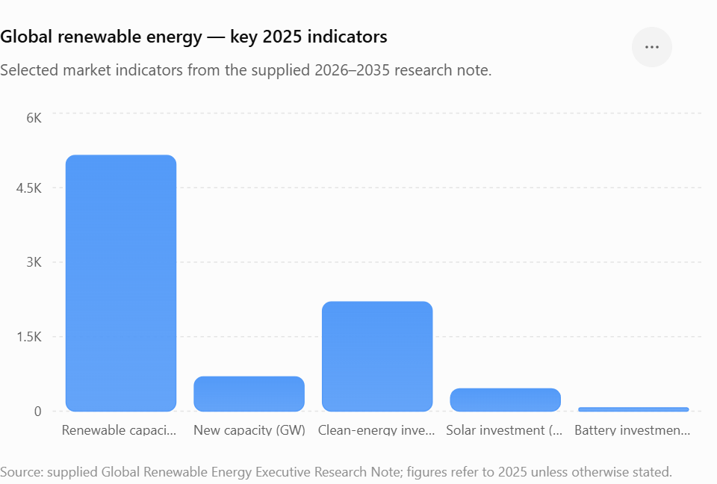
Investment is increasingly moving toward an integrated renewables + grids + storage + electrification + low-carbon fuels ecosystem. Global energy investment is expected to reach $3.3 trillion in 2025, including about $2.2 trillion in clean-energy technologies, approximately twice fossil-fuel investment. Solar investment alone is estimated at $450 billion, while battery-storage investment approaches $66 billion.

Market structure
Dimension | 2026–2035 outlook
Dominant technologies | Solar PV, onshore wind, batteries, hydropower/pumped storage
Fast-emerging | Green hydrogen, offshore wind, advanced geothermal, long-duration storage
Enabling infrastructure | Transmission, distribution, smart grids, power electronics, digital energy
Industrial opportunity | Manufacturing, EPC, O&M, recycling, critical minerals, energy software
Demand drivers | Electrification, AI/data centres, EVs, cooling, industrial decarbonisation, energy security
Major geographic engines | China, EU, US, India, Middle East, Southeast Asia, Latin America and Africa
Key structural trend: the market is shifting from simply installing renewable generation toward managing variable electricity at massive scale. By 2030, wind and solar are expected to provide almost 30% of global electricity, increasing the requirement for grids, storage, demand response and flexible generation.
2. Major sectors, technology and research outlook
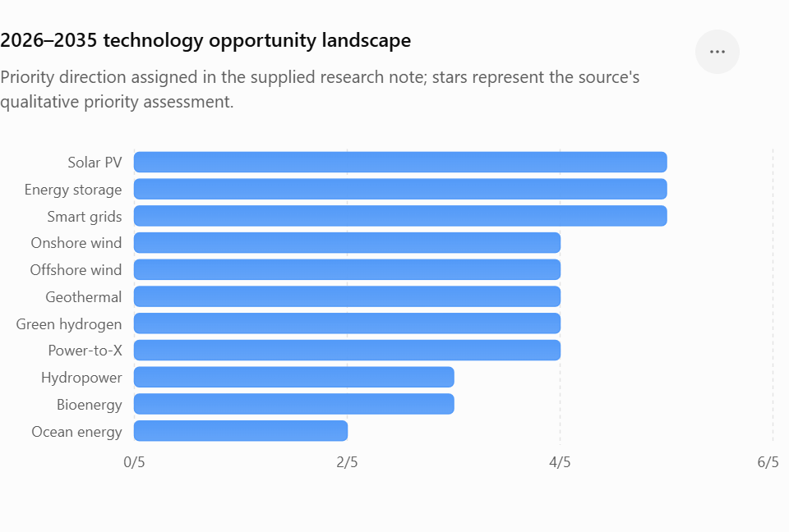
Sector | 2026–2035 direction | Priority research / industrial themes
Solar PV | ★★★★★ | TOPCon/HJT, perovskite-silicon tandem, bifacial, agrivoltaics, floating PV, recycling, advanced inverters
Onshore wind | ★★★★☆ | Larger turbines, advanced materials, predictive maintenance, digital twins, recycling
Offshore wind | ★★★★☆ | Floating offshore wind, subsea cables, larger turbines, corrosion/O&M, hybrid wind-hydrogen
Hydropower | ★★★☆☆ | Pumped storage, modernisation, hybrid hydro-solar/wind, ecological management
Geothermal | ★★★★☆ | Enhanced geothermal systems, closed-loop geothermal, drilling innovation
Bioenergy | ★★★☆☆ | Sustainable biomass, biogas/biomethane, waste-to-energy, BECCS
Green hydrogen | ★★★★☆ | Electrolysers, low-cost renewable H₂, ammonia/e-fuels, storage, pipelines
Energy storage | ★★★★★ | LFP/Na-ion/solid-state batteries, long-duration storage, thermal storage, recycling
Ocean energy | ★★☆☆☆ | Tidal, wave and marine-current technologies; currently less commercially mature
Smart grids | ★★★★★ | AI forecasting, virtual power plants, grid-forming inverters, flexibility markets
Power-to-X | ★★★★☆ | Green fuels, ammonia, methanol, synthetic hydrocarbons
Solar and wind remain the central growth engines. IEA expects wind capacity to approach 2,000+ GW by 2030, while geothermal additions could reach a record level by 2030.

🔬 Research frontier
The most important research transition is from “cheaper generation” to “higher efficiency + flexibility + system integration.”
High-value research areas include:
- Perovskite/tandem PV and high-efficiency solar cells
- AI/ML-based renewable forecasting and predictive maintenance
- Grid-forming inverters and advanced power electronics
- Battery degradation modelling and second-life applications
- Sodium-ion and solid-state batteries
- Long-duration energy storage
- Green-hydrogen electrolyser efficiency and durability
- Advanced geothermal drilling and closed-loop systems
- Floating offshore wind
- Renewable-energy digital twins
- Hybrid renewable-energy parks
- Carbon-aware industrial electrification
- Renewable-powered desalination and water treatment
- Recycling of PV modules, batteries and wind-turbine materials
- Critical-mineral substitution and circular supply chains

3. Applications, demand and expansion
The largest opportunity is sector coupling: renewable electricity increasingly becomes the input for transport, buildings, industry, hydrogen and digital infrastructure.

High-growth applications
Power: utility-scale solar/wind, distributed generation, microgrids and renewable PPAs.
Industry: renewable electricity for steel, chemicals, cement, mining, refining, heat and electrolysis.
Transport: EVs, charging infrastructure, renewable fuels, green hydrogen and sustainable aviation fuels.
Buildings: rooftop PV, batteries, heat pumps, solar thermal and energy-management systems.
Agriculture: solar irrigation, cold chains, agrivoltaics, biomass/biogas and distributed storage.
Water: renewable-powered desalination, RO systems, wastewater treatment and water-energy integration.
Digital infrastructure: data centres and AI computing are creating additional demand for reliable low-carbon electricity.
Hydrogen: particularly relevant to fertiliser, refining, steel, shipping, aviation fuels and long-duration energy storage. More than 200 low-emissions hydrogen projects have reached committed-investment status, although project delays and cancellations remain significant.

👥 Human Capital Workforce
Renewable-energy employment reached at least 16.6 million jobs globally in 2024. China accounted for approximately 44%, followed by the EU, Brazil, India and other Asian markets.
Demand should increasingly favour hybrid technical professionals combining engineering with digital, data, project-management, regulatory or commercial skills.

4. Government policy & regional outlook
Region | Policy direction & market significance
EU | Binding minimum 42.5% renewable-energy share by 2030, aiming for 45%; REPowerEU, permitting reform, industrial decarbonisation, grid investment and post-2030 renewable framework development.
USA | Federal clean-energy incentives have stimulated solar, storage, manufacturing and clean-energy investment, although policy/regulatory changes create greater uncertainty for 2026–2030 deployment. IEA has consequently sharply revised its US renewable forecast downward.
China | Global manufacturing and deployment leader. Its 2035 NDC targets wind + solar capacity above 3,600 GW, more than six times 2020 levels.
India | Target of 500 GW non-fossil capacity by 2030; India reached 50% of cumulative installed electricity capacity from non-fossil sources in June 2025. Green Hydrogen Mission targets 5 Mt/year by 2030.
Middle East | Strong solar, storage and green-hydrogen expansion driven by energy diversification, industrial policy and export potential. Saudi Arabia/UAE are emerging as major renewable-H₂ and clean-power investment hubs.
Africa | Major long-term opportunity in solar, mini-grids, storage, hydro, geothermal and renewable-powered industrial development; financing and transmission remain constraints.
Latin America | Strong solar/wind resources, hydro base and growing green-hydrogen/e-fuel potential, particularly Brazil, Chile and Mexico.
Southeast Asia | Rapid electricity-demand growth creates opportunities in solar, wind, storage, grids, geothermal and industrial decarbonisation.

5. Critical challenges and risks

1. Grid bottlenecks
Generation is frequently being built faster than transmission/distribution infrastructure. Curtailment and negative electricity prices are emerging in several major renewable markets.

2. Storage
Rapid solar/wind deployment requires much greater flexibility. IEA estimates that global storage capacity would need to increase sixfold to 1,500 GW by 2030 in its Net Zero pathway, with batteries providing most of the growth.

3. Supply-chain concentration
China remains exceptionally dominant in PV manufacturing and critical mineral processing. IEA expects key PV and rare-earth supply-chain concentration to remain above 90% in important segments through 2030.

4. Financing
High interest rates, project-development risk, permitting delays and weak electricity-market design can undermine otherwise competitive projects.

5. Critical minerals
Lithium, nickel, cobalt, copper, graphite and rare earths create geopolitical and environmental vulnerabilities.

6. Offshore wind economics
Higher financing, material and supply-chain costs have caused project cancellations/delays and reduced near-term deployment expectations.

7. Environmental/social issues
Land use, biodiversity, water requirements, mining impacts, recycling, community acceptance and indigenous/community rights increasingly affect project timelines.
6. 2026–2035: Top 10 high-potential opportunities
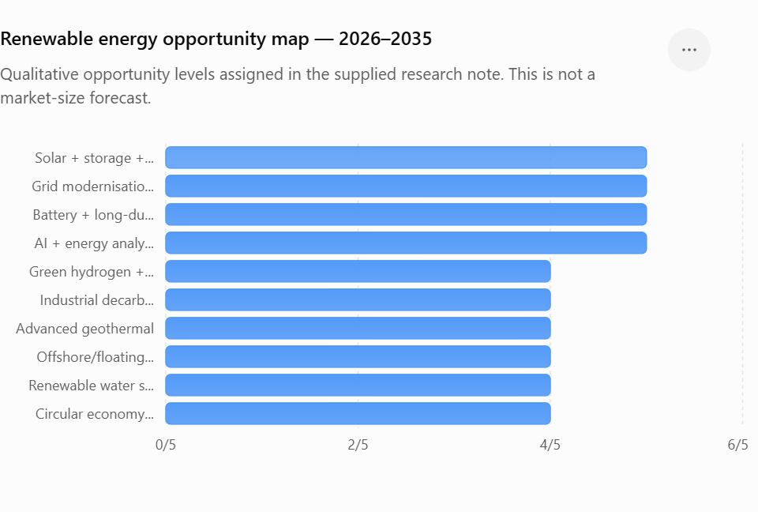
Rank | Opportunity | Potential
1 | Solar PV + battery storage + smart-energy systems | ★★★★★
2 | Grid modernisation, transmission & digital grids | ★★★★★
3 | Battery/long-duration energy storage | ★★★★★
4 | AI + renewable-energy analytics/digital twins | ★★★★★
5 | Green hydrogen + derivatives | ★★★★☆
6 | Renewable-powered industrial decarbonisation | ★★★★☆
7 | Advanced geothermal | ★★★★☆
8 | Offshore/floating wind | ★★★★☆
9 | Renewable-powered water/desalination & wastewater systems | ★★★★☆
10 | Circular economy: battery/PV/wind recycling + critical minerals | ★★★★☆

Strategic outlook
2026–2030: deployment dominates. Solar PV, batteries, grids, distributed energy, EV infrastructure and power-system digitalisation should generate the largest near-term commercial opportunities.
2030–2035: the market progressively shifts toward system integration, firm renewable power, long-duration storage, hydrogen, advanced geothermal, offshore wind, AI-enabled energy management and industrial electrification.
The strongest long-term business model is therefore unlikely to be a standalone renewable-generation company. The higher-value ecosystem is:
Renewable generation → storage → grid → digital control → electrification → hydrogen/industrial applications → recycling/circular economy
This also explains why renewable energy should be viewed as an interdisciplinary industrial ecosystem, rather than simply a solar/wind market.

🌐 Global Market Signals
The evidence also points to a major geographic shift: China remains the dominant deployment/manufacturing engine, while Europe, India, the Middle East, Southeast Asia, Africa and Latin America provide substantial new project-development and infrastructure opportunities. Solar PV is likely to remain the volume leader, but storage, grids and system-integration technologies may become the most strategically important enabling sectors.
Bottom line
The sector has exceptionally strong 2026–2035 structural growth prospects, but deployment alone is becoming less differentiated. The most defensible research and commercial opportunities will increasingly sit at the interfaces between renewables + storage + grids + AI + hydrogen + industrial decarbonisation + advanced materials + water/transport systems
Core sources: IEA Renewables 2025, World Energy Investment 2025, Global Energy Review 2026, Batteries and Secure Energy Transitions and Global Hydrogen Review 2025; IRENA Renewable Capacity Statistics 2026 and Renewable Energy and Jobs 2025; European Commission renewable-energy framework; Government of India/MNRE; Government of China.

